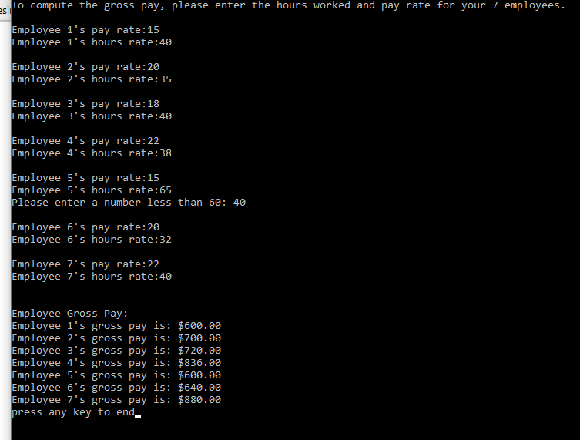

Note employee 5 displays the hours < 60 check

